Due Diligence Automation System
User Manual

Version 1.0
1-August-2017

Developed by:
Clarity Information Technologies Pvt. Ltd.
Bangalore.
Tele: 080 - 2529 1698
Email: mail@claritytechnologies.com

Table of Contents
Revision History 3
Introduction 3
1 Application Environment 4
1.1 Application Architecture 4
1.2 Application Servers 4
1.3 Database Servers 4
1.4 System Functions and or Services 5
1.5 Backups/Restores 5
2 Support Procedures 5
2.1 Obtaining Access 5
2.2 Common Problems/Troubleshooting 5
2.3 Application Restart Process 6
2.4 Migration Steps 6
Data Extraction Error: 7
Annexure: 8
1. FDA Debarment List 10
2. Clinical Investigator Inspection List (CLIL)(CDER) 10
3. FDA Warning Letters and Responses 11
4. Notice of Opportunity for Hearing (NOOH) – Proposal to Debar 12
5. Adequate Assurances List for Clinical Investigators 13
6. Clinical Investigators – Disqualification Proceedings (FDA Disqualified/Restricted) 13
7. Clinical Investigator Inspection List (CBER) 14
8. PHS Administrative Actions Listing 14
9. HHS/OIG/ EXCLUSIONS DATABASE SEARCH/ FRAUD 14
10. HHS/OIG Corporate Integrity Agreements/Watch List 15
11. SAM/SYSTEM FOR AWARD MANAGEMENT 16
12. LIST OF SPECIALLY DESIGNATED NATIONALS 17

Revision History

Date | Version | Section | Description | Author
 |  | All | Initial | Pradeep / Johnly

Introduction

DDAS is a Web Application and can be accessed through: http: ddas … and http:ddastest…
The main goal of the DDAS application is to aid the user to collate Investigator and Institute related Complaince Issues into Investigator Compliance Search Forms (ICSF).
The application collects Investigator Compliance related data from various pubic sources. The application downloads this every 24 hours and converts it into data repositories.
The application user inputs details such as Project Number, Name of Institute, Country, List of Investigators and their Role, Prinicpal or Sub. The application scans through the latest version of the data repositories for suitable match of Invesigator Name and presents the results to the user for recording observations.
The data is extracted from the following web sites –
- FDA Debarment List
- Clinical Investigator Inspection List (CLIL)(CDER)
- FDA Warning Letters and Responses
- Notice of Opportunity for Hearing (NOOH) – Proposal to Debar
- Adequate Assurances List for Clinical Investigators
- Clinical Investigators – Disqualification Proceedings (FDA Disqualified/Restricted)
- Clinical Investigator Inspection List (CBER)
- PHS Administrative Actions Listing
- HHS/OIG/ EXCLUSIONS DATABASE SEARCH/ FRAUD
- HHS/OIG Corporate Integrity Agreements/Watch List
- SAM/SYSTEM FOR AWARD MANAGEMENT
- LIST OF SPECIALLY DESIGNATED NATIONALS

Application Environment

Application Architecture

Application Servers
Web Servers
Function | IP Address | Server Name | Physical Location | Software | Version
Prod
Test

Files Shares
Function | \\Server\Share | Physical Location
Prod
Test
Del
Dev

Folder Structure
Path | Notes

Access Groups
Function | GroupName | Access Rights
Prod
Test
Del
Dev

Database Servers
Database Servers
Function | IP Address | Server Name | Physical Location | Software | Version
Prod | 10.10.10.1 | Kitkat | 4000 Seymour | Oracle | 10.0.1.2
Test
Del
Dev

Database Instances
Function | Server | Instance | Notes
Prod
Test
Del
Dev

System Functions and or Services
Batch Schedulers.

Print Queues
System Jobs

Updating the Job Scheduler

Backups/Restores
Handled by ICON IT.

Support Procedures

Obtaining Access
NT Security Request
Application Access request
BCEID request

Common Problems/Troubleshooting

Application not responding
Database down
Access Denied
CLP Issues
Common browser error messages

Application Restart Process
User Sessions
Notifications
Links to other systems

Migration Steps
Refer to appropriate document.

Data Extraction Error:

DDAS application downloads/extracts data from 11 FDA sites every day. The download status of these websites provided in the application is shown below.
Extractor Indicator
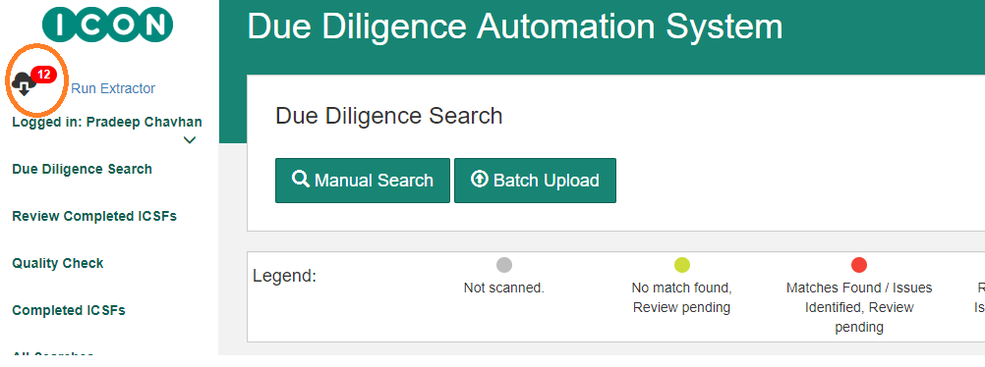

Data Extractor
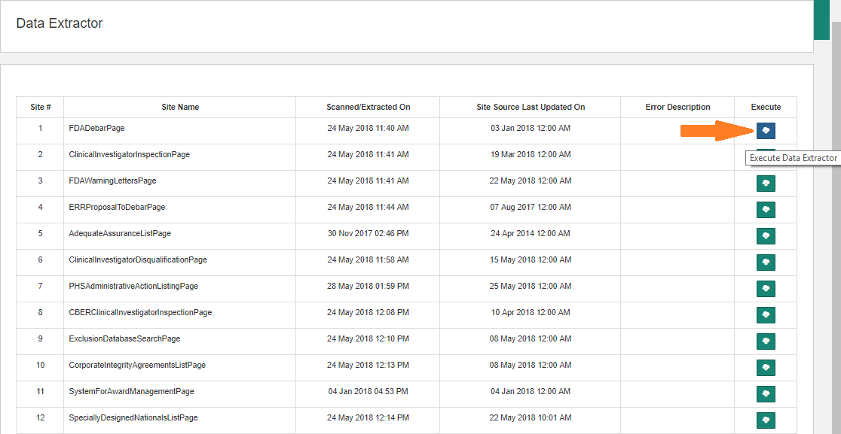

- As indicated in the above screenshot – Extractor Indicator, the number of sites for which the data has not been extracted is shown in red colour
- ‘Run Extractor’ link next to the Extractor Indicator appears only for admin. This link will navigate to ‘Data Extractor’ page as per the above screenshot ‘Data Extractor’
- As indicated in ‘Run Extractor’ page, data can be extracted for any site. In case of success, the message is shown as below
- The extraction message in case of failure is shown as below
(On successful data extraction)
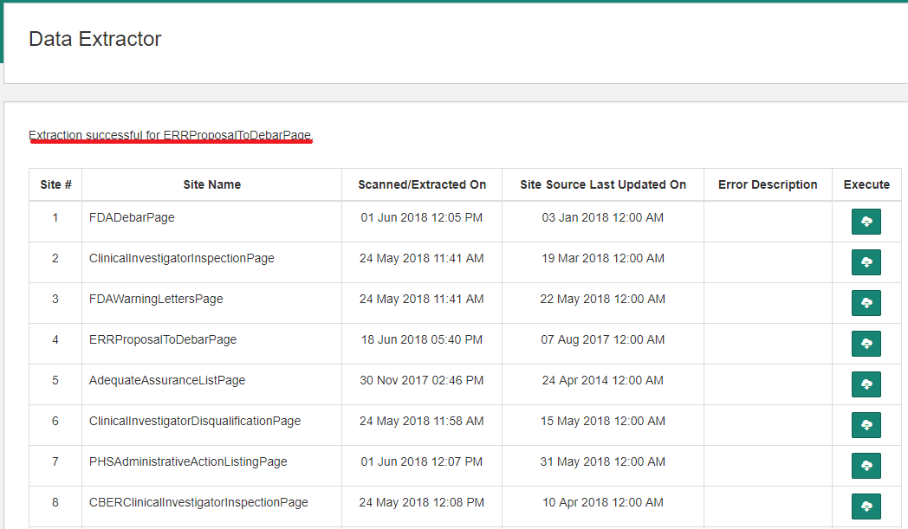

(On failure)
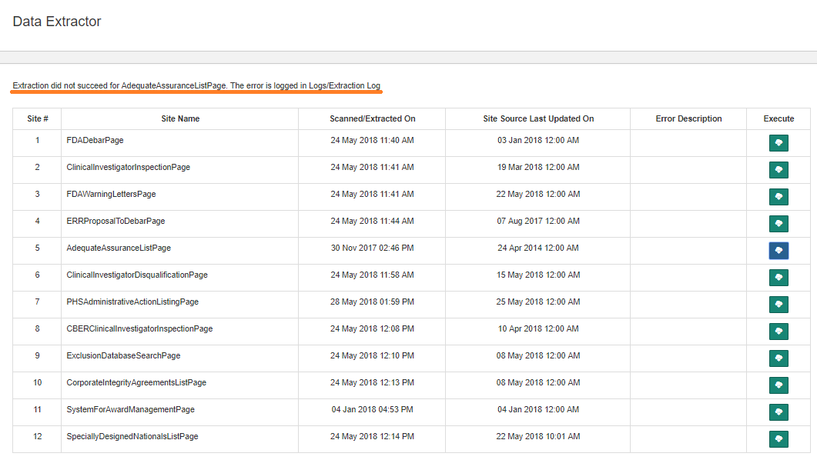
- If extraction fails, navigate to the site (refer Annexture-1) and check whether the site is accessible

Annexure:

Below are the active links for the sites for which data extraction is carried out
Serial Number | Site Name | Site Url
1 | FDA Debarment List | http://www.fda.gov/ora/compliance_ref/debar/default.htm
2 | Clinical Investigator Inspection List (CLIL)(CDER) | https://www.fda.gov/Drugs/InformationOnDrugs/ucm135198.htm
3 | FDA Warning Letters and Responses | https://www.accessdata.fda.gov/scripts/warningletters/wlSearchResultExcel.cfm?qryStr=
4 | Notice of Opportunity for Hearing (NOOH) – Proposal to Debar | http://www.fda.gov/RegulatoryInformation/FOI/ElectronicReadingRoom/ucm143240.htm
5 | Adequate Assurances List for Clinical Investigators | http://www.fda.gov/ora/compliance_ref/bimo/asurlist.htm
6 | Clinical Investigators – Disqualification Proceedings (FDA Disqualified/Restricted) | http://www.accessdata.fda.gov/scripts/SDA/sdNavigation.cfm?sd=clinicalinvestigatorsdisqualificationproceedings&previewMode=true&displayAll=true
7 | Clinical Investigator Inspection List (CBER) | http://www.fda.gov/BiologicsBloodVaccines/GuidanceComplianceRegulatoryInformation/ComplianceActivities/ucm195364.htm
8 | PHS Administrative Actions Listing | https://ori.hhs.gov/ORI_PHS_alert.html?d=update
9 | HHS/OIG/ EXCLUSIONS DATABASE SEARCH/ FRAUD | https://oig.hhs.gov/exclusions/exclusions_list.asp
10 | HHS/OIG Corporate Integrity Agreements/Watch List | http://oig.hhs.gov/compliance/corporate-integrity-agreements/cia-documents.asp
11 | SAM/SYSTEM FOR AWARD MANAGEMENT | https://www.sam.gov/portal/public/SAM
12 | LIST OF SPECIALLY DESIGNATED NATIONALS | http://www.treasury.gov/resource-center/sanctions/SDN-List/Pages/default.aspx

1. FDA Debarment List
Data File Downloaded: No
Contents in the table indicated below are extracted and saved into database
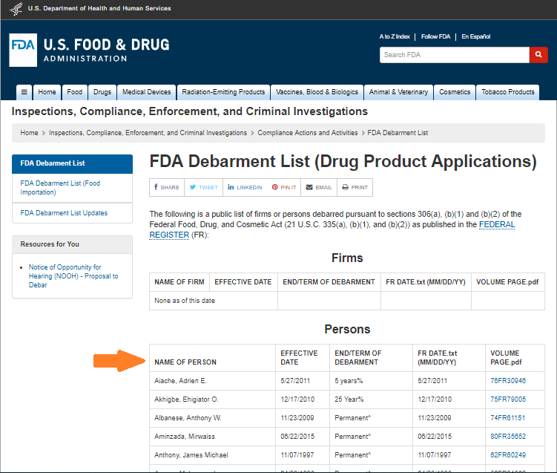

2. Clinical Investigator Inspection List (CLIL)(CDER)
Data File Downloaded: Yes
Data file is downloaded from the link indicated below and the data is saved into database
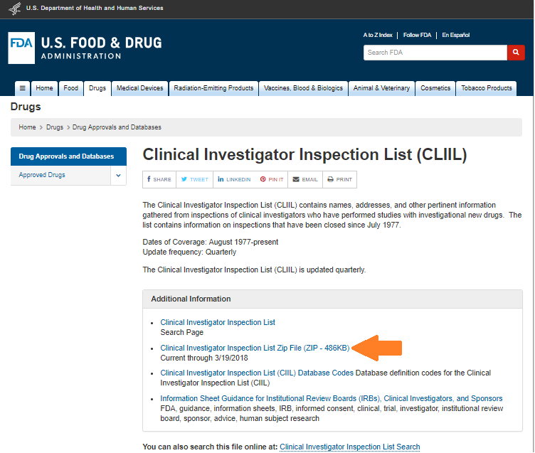

3. FDA Warning Letters and Responses
Data File Downloaded: Yes
The given link directly downloads the file. Data is then saved into database

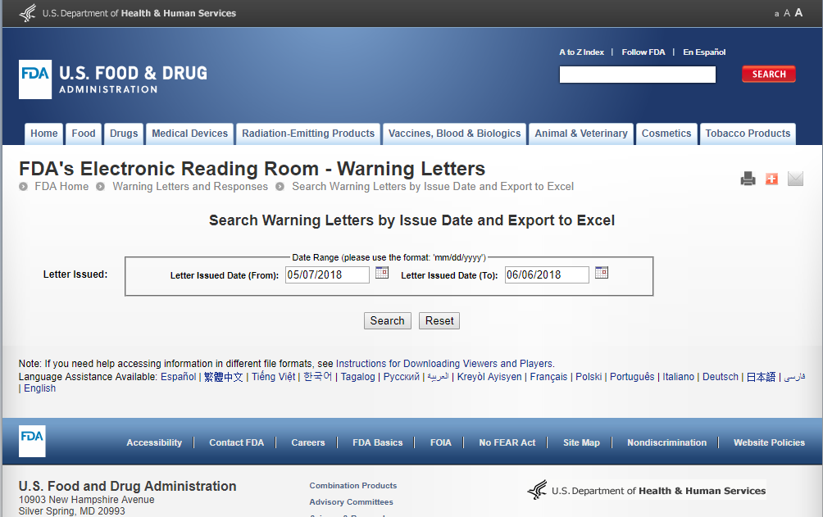

4. Notice of Opportunity for Hearing (NOOH) – Proposal to Debar
Data File Downloaded: No
Contents in the table indicated below are extracted and saved into database

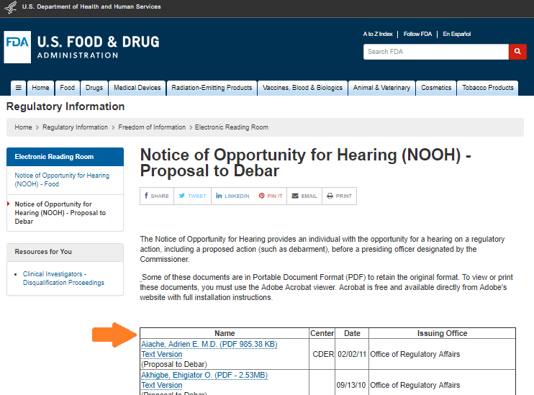

5. Adequate Assurances List for Clinical Investigators
Data File Downloaded: No
Currently this site is down

6. Clinical Investigators – Disqualification Proceedings (FDA Disqualified/Restricted)
Data File Downloaded: No
Contents in the table indicated below are extracted and saved into database
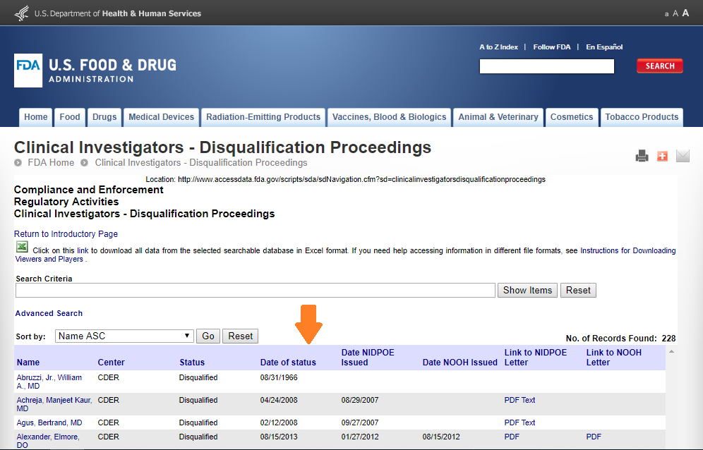

7. Clinical Investigator Inspection List (CBER)
Data File Downloaded: No
Contents in the table indicated below are extracted and saved into database
Data is extracted for all the lists: A-D, E-K, L-P, Q-S and T-Z
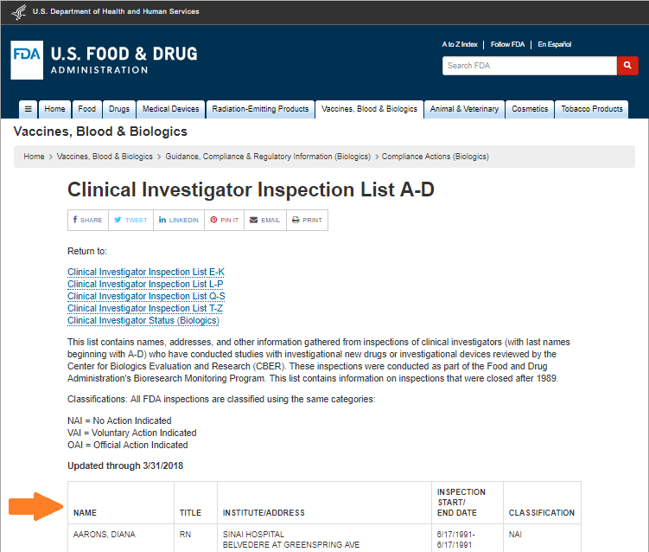

8. PHS Administrative Actions Listing
Data File Downloaded: No
Contents in the table below are extracted and saved into database
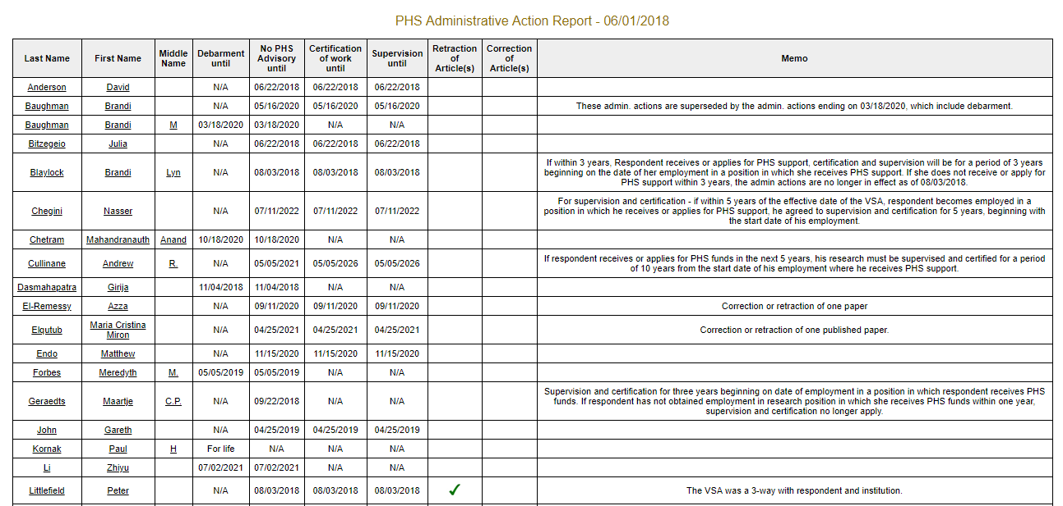

9. HHS/OIG/ EXCLUSIONS DATABASE SEARCH/ FRAUD
Data File Downloaded: Yes
Data file is downloaded from the link indicated below and the data is saved into database
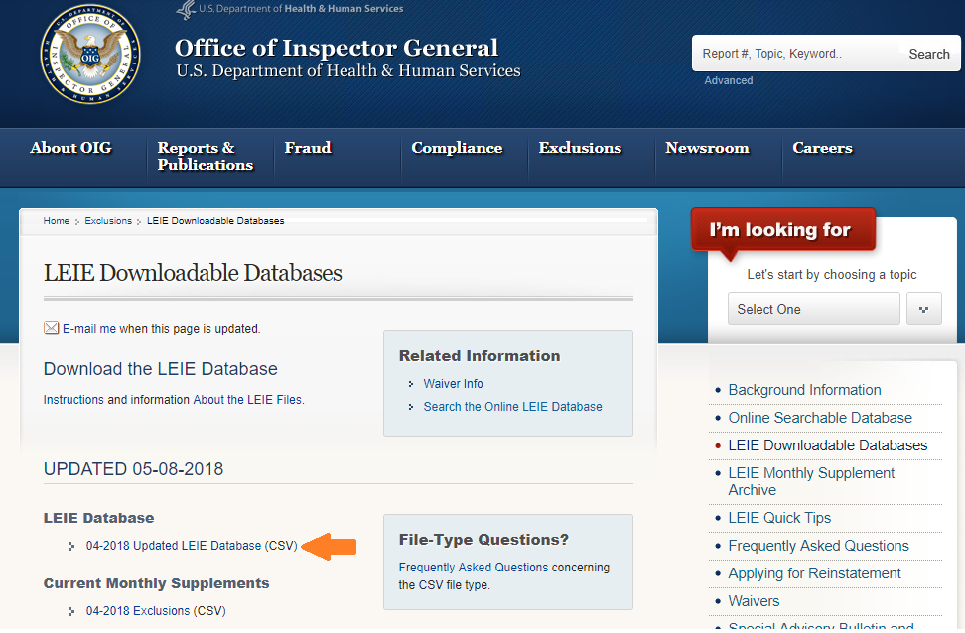

10. HHS/OIG Corporate Integrity Agreements/Watch List
Data File Downloaded: No
Contents in the table indicated below are extracted and saved into database (From A to Z)
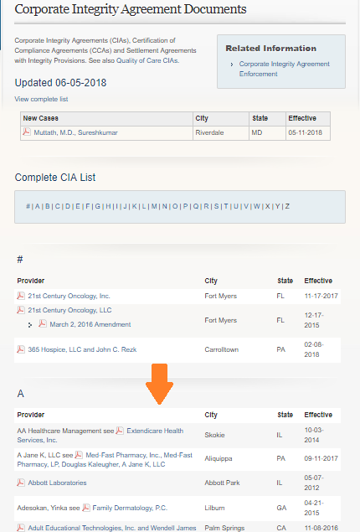

11. SAM/SYSTEM FOR AWARD MANAGEMENT
Data File Downloaded: Yes
Below is the Home Page
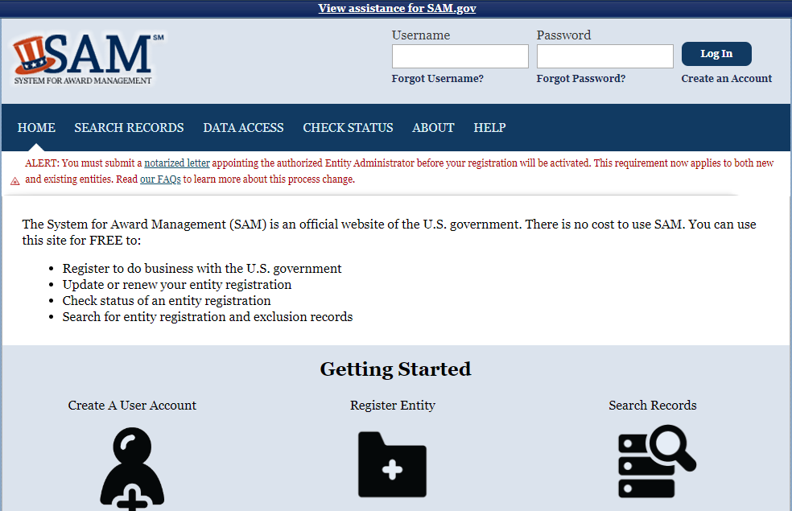
Navigate to the ‘DATA ACCESS’ page. At the bottom of the page, ‘Exclusion Extract Data Package’ table is displayed, as shown below. This table contains past 7 days files of exclusion extract lists. Download the last file to get the most recent exclusion extract data as shown below
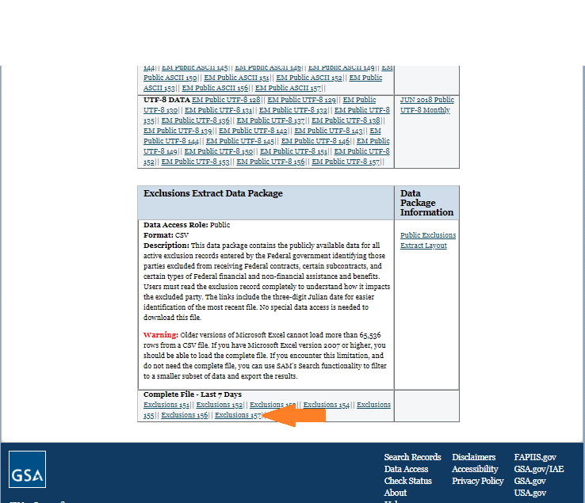

12. LIST OF SPECIALLY DESIGNATED NATIONALS
Data File Downloaded: Yes
Data file is downloaded from the link indicated below and the data is saved into database
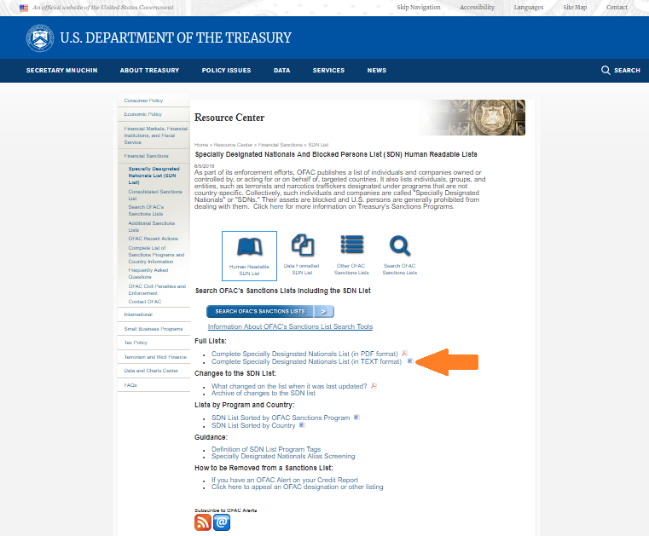

Test Foot Note

